SRA ROAD SAFETY WORKING GROUP AND RVR ROADS GROUP - SPEEDING
Bromley Council has a duty to manage the road network, to balance the flow of traffic with the safety of pedestrians and road users. As a group, speeding is one of our main concerns, particularly on the roads used as rat runs.
There are currently only two speed checks per month in this ward, which may sometimes not be provided due to other priorities:
- The Council needs to maintain the minimum
- We propose that the minimum is increased whenever possible, and the associations will provide volunteers for the Roadwatch scheme to help with this
TFL is responsible for speed cameras across the whole of the Greater London area:
- We encourage the Council to consult with TFL about increasing the number of speed cameras in the borough
- Mobile cameras may be a more cost-effective option
The following areas have been identified as being of particular concern:
- Hayes Lane
- Bromley Road
- Shortlands Road
- Kingswood Road
- St Mary’s Avenue/Cumberland Road
- Ravensbourne Avenue/Farnaby Road
- Bromley Avenue
- Glassmill Lane/Queens Mead Road
As far as the last three areas are concerned, we have a specific suggestion for a traffic control priority system, with a widened pavement, which would address both speeding and pedestrians crossing these dangerous roads. Such a scheme is already in place at Churchfields and Kings Hall Roads in Beckenham – see photos below.
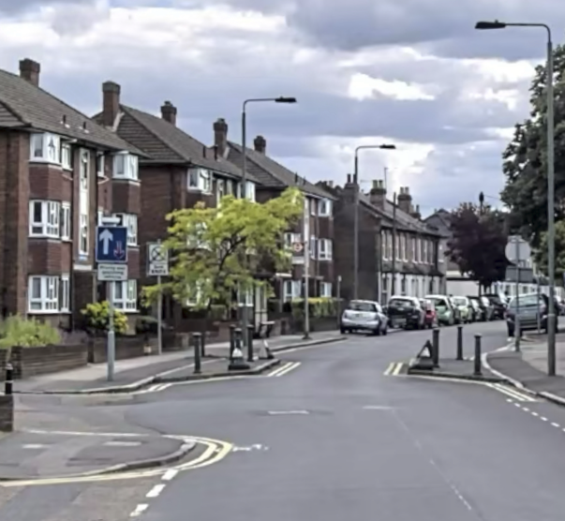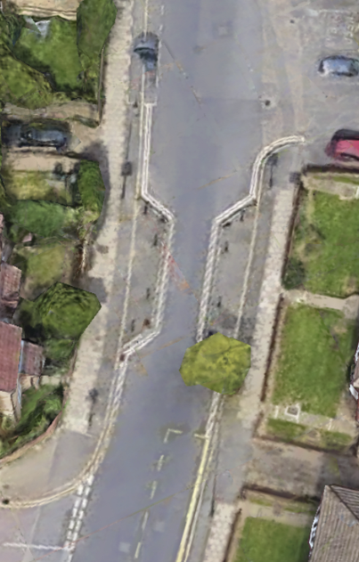
Please see the attachment for more precise details and proposals.
(you may need to click on ‘enable editing’ to open the attachment)
(29Nov 24)

