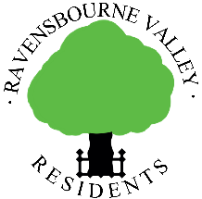
Everything you always wanted to know about planning but were too afraid to ask

This document contains, in the first part, information about planning in general (e.g. how one might respond to an application for a new block of flats) and in the second part information about Tree Preservation Orders. It tends to be Bromley-centric but the issues apply to Lewisham too.

Planning in general

Where does it all start?

Our involvement with planning applications is usually stimulated by the ‘Weekly List’. The Weekly List is a list, produced weekly by Bromley’s Planning Department, of all applications, decisions and appeals made in the previous week. On request, the planning department can add you to the mailing list to receive it every Monday morning.

With regard to Lewisham applications, we are automatically advised of new developments in ‘our’ Lewisham Roads (Calmont, Coniston, Hillbrow and Ashgrove Roads and Ambleside) as a result of ‘saved’ searches (see below)

When a planning application is submitted, very near neighbours and other interested parties are advised of it and given three weeks to make any comments. Residents’ Societies might be advised of planning applications in this way but generally they have to rely upon regular scrutiny of the weekly list. It is at this point that Residents’ Societies and residents might contact their Councillors to seek support in objecting to applications.

Searching London Borough websites’ Planning Pages

Information about applications can be found on the search page of the Bromley web site.

This page is a gateway to most information that one needs about specific applications. This is it:
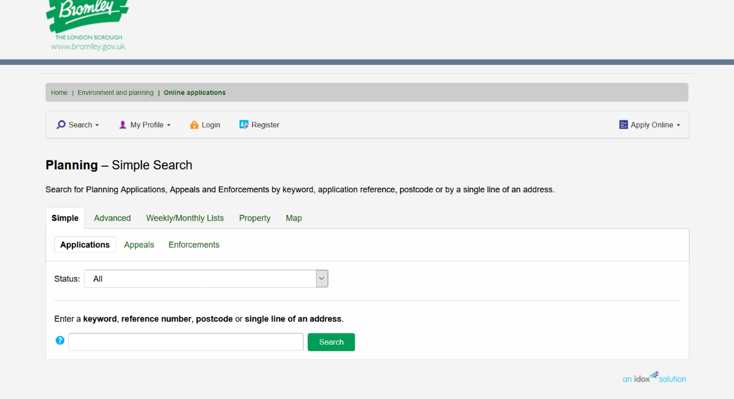

Putting in a reference number (15/01673 in this case) in the above screen, press ‘search’ and you get this screen:

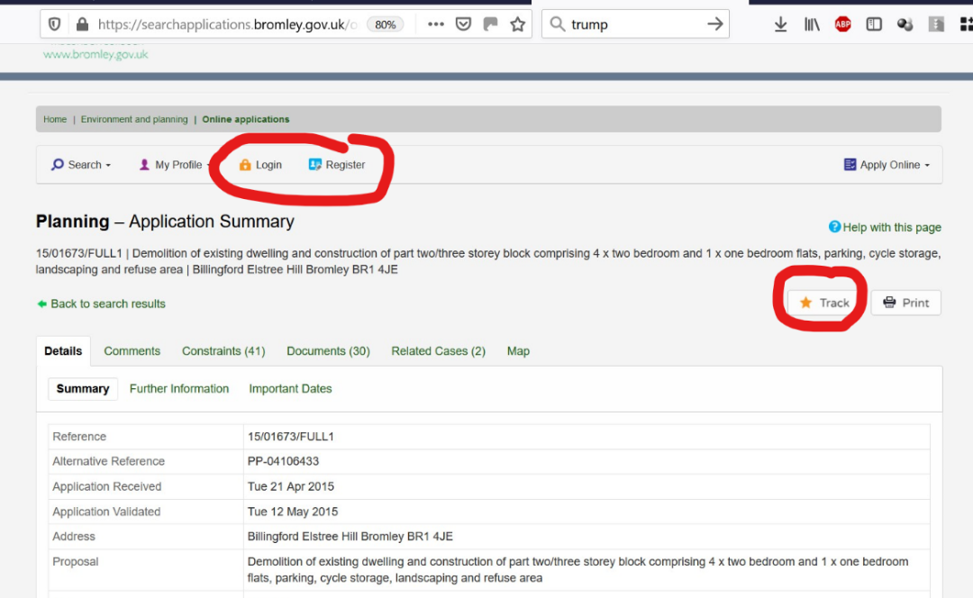

The page above has useful information including ‘Important Dates’ and ‘Documents’. These documents are the plans and other documents relating to the application.
NOTE: You can register, log in and then ‘Track’ the application – this means you will be notified as soon as anything happens with the application – e.g. for example, the decision process being moved up a level. The search screen also allows you to save your search and be advised when relevant applications crop up.

How decisions are made

For applications involving three or fewer units, and which are otherwise uncontentious, the Borough’s Chief Planning Officer himself can make a decision under ‘delegated powers’. For larger or contentious applications, the application is referred to one of the four planning Sub-Committees, meeting fortnightly, together with a recommendation of either ‘permission’, ‘refusal’ or ‘members’ views requested’. The Councillors sitting on each Sub-Committee are not bound to accept this advice – but see below. In addition, there is Development Control Committee, DCC, which reviews important planning applications and strategic planning issues.

Also, when an application is considered by a Committee, it is possible for members of the public to speak for 3 minutes either for or against the application. Important information about this is included in the appendices below.

What gets taken into account when deciding an application?

Amongst other things, the Chief Planning Officer (‘CPO’) (or rather any one of the Council’s Planning Officers) considers whether the application meets the policies in the Local Plan. Applications can only be refused because they fail to fulfil the Local Plan Policies (or national policies or the London Plan where these apply).

For some issues, the CPO seeks reports from specialists within the Council, notably the Highways Department who comment on issues such as parking and access. These reports from specialists confirm whether or not there are any ‘technical issues’ on which an application can be refused. If there are none, and then the Planning Officer or the Sub-Committee refuses the application anyway (e.g., the Highways Department says there are no parking issues but the Sub-Committee thinks there are and refuses permission on this basis) then the Council is likely to have to pay costs at any subsequent Appeal.

General planning information can be found here:- https://www.planningportal.co.uk/

There is an excellent decision by Bromley hosted on our website which is a very detailed refusal for a development at 8 Madeira Avenue, which was contentious.
While it is far, far more detailed than RVR would ever produce it is interesting because it brings together so many issues.

Timetables

The council generally has eight weeks from the start date to make a decision, and failure to do so may result in the applicant registering an appeal on the grounds of “non determination”. For larger applications, the council has up to twelve weeks to make a decision. All these relevant dates and the date of the committee meeting, if any, can be found on the web site.

Applicants can appeal a refusal and these Appeals can be held under a number of different procedures ranging from “house holder” which is determined by the Inspector solely on the basis of the information already held by the Council up to an “inquiry” which is an expensive and formal legal procedure.

Appeals and other information can be found here:- https://acp.planninginspectorate.gov.uk/

Planning issues
Objections to applications can only be made on the basis of applications having failed to meet the policies contained within the Local Plan (particularly useful), which is the planning Bible (or national policies or the London Plan where these apply).

Although there are many policies in the Local Plan which an application might contravene, the major issues tend to be: --

Policy number | Issue
3 | Backland and Garden Land Development
4 | Decent design
8 | Of such a size that the separation between the proposed property and existing properties would not be of the spatial standard of the area
37 | Overdevelopment by way of bulk, mass, height and perhaps footprint. Out of character to the area for example by style or size. Loss of amenity to neighbours.
30 | Insufficient or inappropriate parking arrangements for cars and bikes

In addition, on occasion, Supplementary Planning Documents might apply, and there are guidance documents with respect to the Downs Hill Conservation Area and (to be, we assume) the prospective Shortlands Village Conservation Area

Conditions
Applications are often given permission subject to conditions. Almost invariably this means that the building must be built within three years but conditions can also include taking precautions to protect existing trees, the external materials to be used and the treatment and nature of boundary enclosures.

Importantly, permission is often given subject to a condition about landscaping – i.e. that sufficient trees and shrubs are planted at the development site to help it blend in with the street scene. Frequently, developers fail to plant the trees and shrubs they said they would (to the detriment of all neighbours) and it is often necessary to raise a formal enforcement complaint to ensure that they comply with conditions.

Objecting to an application
It is easiest to object online. Here is an example of a (redacted) real life objection (NB: this objection is based on the Unitary Development Plan, the forerunner of the Local Plan): -
April 2014

Mr. J. Alderman,
Planning Dept.,
LB Bromley,
Stockwell Close,
Bromley

Dear Mr. Alderman,

[Roof alterations and extensions], [ ] Close

We object to this application on the following grounds: -

- UDP Policies BE1(v) and H8(iii)
The proposed dormer window on the second floor is a real cause for concern. Whilst an improvement on the Juliet Balcony of the earlier application, nevertheless there would still be a considerable loss of privacy in gardens from being overlooked and this will particularly affect [ ] Close to the rear. In addition, overlooking down, across and into the bedrooms of 5 and 6 [ ] Close will be unacceptably intrusive. By submitting application 14/[ ] (an application at this site but without the proposed dormer window) the applicant is tacitly admitting that the dormer window would be unacceptable.

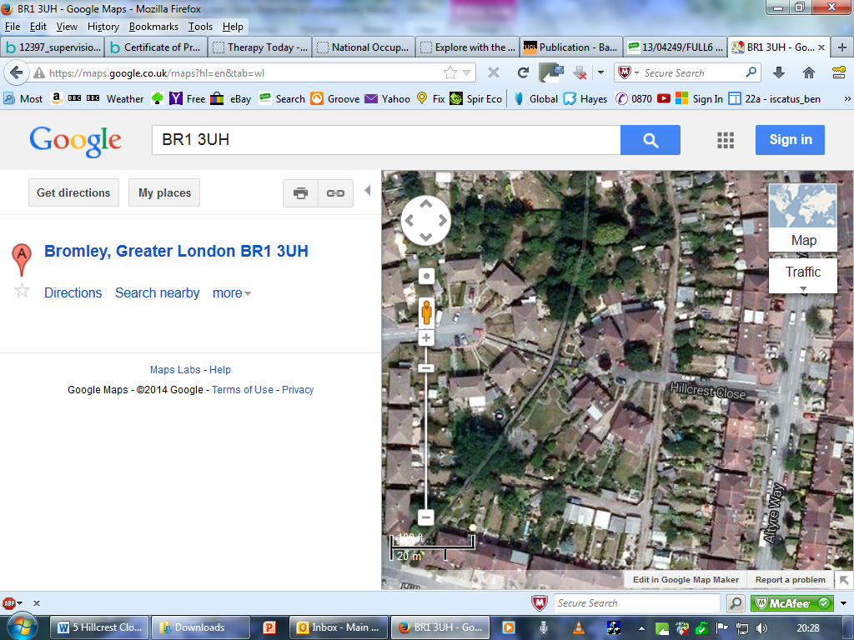

1 Looking down and into gardens and bedrooms

- UDP Policies BE1 (ii) & H8 (i),(ii)
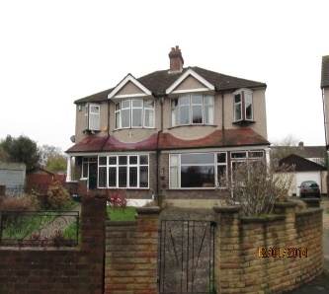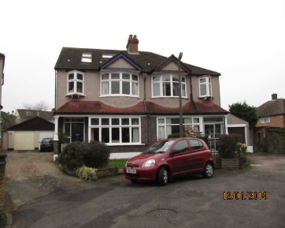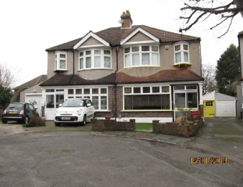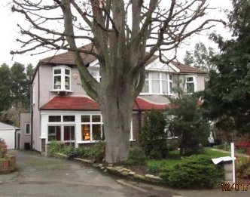

[ ] Close constitutes four pairs of semi-detached houses which, apart from one hipped roof which has been converted to a gable roof, retains a remarkable degree of similarity and indeed symmetry. The addition of a two storey side extension would destroy the symmetry, be over dominant to the main building and impact negatively on the street scene.
- UDP Policies BE1(i) & H7(iii), (iv)

The development site is already cramped and is indeed the smallest plot in [ ] Close. The development would result in a very small and inadequate garden. Again, the applicant, by submitting application 14/[ ] (which has no rear extension), tacitly accepts that this application is excessive.

The proposal constitutes a cramped overdevelopment of the site resulting in an over intensive use of the site and retrograde lowering of spatial standards to which the area is at present developed.

2 The plot is already the most cramped
and awkward in [ ] Close

- UDP Policy T3 Parking

We note that Section 8 of the Application Form states incorrectly that parking arrangements would not be affected by this proposal: clearly they would be as the garage will be demolished.

We are concerned that with the proposed removal of the parking space (garage) and the addition of living space to the property in question, there would be additional pressure on street parking. We understand that should the property be extended, there will be three vehicles and a van to be accommodated. Parking is limited in [ ] Close either because the access is narrow (below left picture) or because space is needed for manoeuvring at the head of [ ] Close.

Further, [ ] Way (below right) has many dropped curbs for vehicular access and as such parking in this road is somewhat limited.
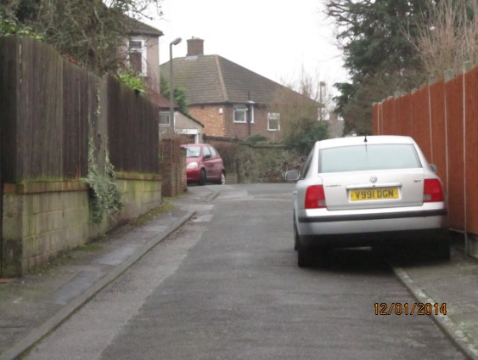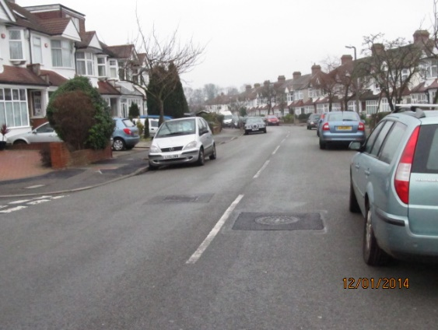

As a result, the excess parking is likely to lead to unsafe road conditions.

Conditions
Without prejudice to the foregoing, if the Council is minded to permit this application, then we would request that the following conditions are raised: -

- Construction Method Statement
No development shall take place, including any works of demolition, until a Construction Method Statement has been submitted to, and approved in writing by, the local planning authority. The approved Statement shall be adhered to throughout the construction period. The Statement shall provide for:

- the parking of vehicles of site operatives and visitors
- the timing of deliveries
- loading and unloading of plant and materials

Reason: access to the site is via a narrow road and parking near the site is limited or likely to cause obstruction. In addition, lorries over 5 tons are already prohibited from entering [ ] Close outside of the hours 08:00 to 18:30.

- Working Hours
Demolition or construction works shall not take place outside 08:00 hours to 18:00 hours Mondays to Fridays and 09:00 hours to 13:00 hours on Saturdays nor at any time on Sundays or Bank Holidays.

Reason: the site is in a quiet residential area and the residents might reasonably expect not to be inconvenienced by noise.

- Materials
In particular, and as far as possible, materials must match those of 6 [ ] Close.

For all these reasons, we ask you to refuse this application.

Yours sincerely,

2) Trees and their Conservation
This note is a quick introduction to the protection of trees in our area.

Trees in our area are protected by one of three means.

1) Within the Downs Hill Conservation Area
The law requires that anyone planning to cut down or carry out work to a tree in a conservation area must legally give the Council six weeks’ notice of their intention to do so. The purpose of this notice is to give the Council the opportunity to consider whether a Tree Preservation Order should be made.
You do not need to notify the Council if you want to cut down or work on a tree that is less than 7.5 cm in diameter (measured 1.5 m above ground) or 10 cm if you are thinning to help the growth of other trees. There is also no need to follow the notification procedure when a tree is dead, dying or has become dangerous and action needs to be taken quickly for safety reasons, although you should let the Council know if you are taking down a tree in these circumstances.

If in doubt contact the Tree Officer on:

Telephone: 020 8313 4516
e-mail: trees@bromley.gov.uk

2) Within the area covered by various ‘blanket’ Tree Preservation Orders
A large part of our area is covered by ‘blanket’ tree preservation orders and the approximate area covered by these is shown in the map below.

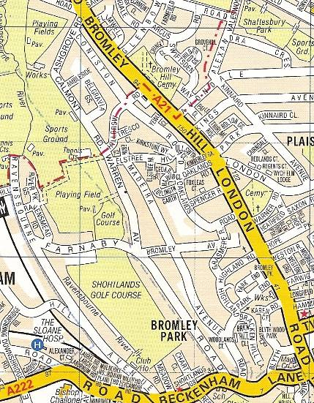
In essence, no work may be carried out on trees within this area without the council’s permission but full details can be found here.

3) Spot Orders
Within our area, a large number of trees are covered individually by so called ‘spot orders’. Individual owners of these trees will know of the Preservation Order. The rules are the same as for those trees covered by a blanket order – please see the above link for further details.

Concerns about trees
If you have any concern that a tree should be protected, or believe that work has been carried out to a protected tree please do not hesitate to contact council on

Telephone: 020 8313 4516
e-mail: trees@bromley.gov.uk
https://www.bromley.gov.uk/info/508/trees/1061/tree_protection/5

It should be noted that trees are often at risk in the period immediately before a planning application is submitted.

Help
Members should feel free to contact RVR at planning.rvr@outlook.com if you require any assistance with planning issues.

Ravensbourne Valley Residents
November 2020

Appendix one
If you have the opportunity to speak for 3 minutes in front of a committee, please read the following which we have prepared to assist you.

The Bromley Council has produced the advice below on the matter. In addition to the formal advice provided by Bromley, speakers may wish to take the following into account.

- Find out which committee is hearing the application here having found out the date of the meeting from the ‘important dates’ page of an application – typically like this.
- Prior to the meeting, the Council Planning Officer’s ‘delegation report’ on the application will be available here or on the ‘documents’ page of an application, typically like this .

By tracking your application (which you can do after ‘searching’ for it on the council website, and after ‘logging in’) you will receive notification when this report is available.

The report will tell you whether Permission is recommended or not.

- Speakers are required to attend half an hour before the meeting in order to register. They then sit at the front of the public gallery in the council chamber waiting their turn to speak.
- It is always highly recommended to get a Councillor to speak against the application as well as yourself. This ensures that the application is dealt with early in the evening, rather than having to wait, literally, for hours.
- When you speak, remember to switch the microphone on!
- Prepare a speech thoroughly beforehand of approximately 400 words – the most that can be reasonably spoken in 3 minutes.
- Your speech should concentrate only on planning issues e.g. out of character with the locality, too big, too high, loss of amenity and privacy. Importantly, inconvenience from demolition /construction or loss of property values are not planning issues and therefore irrelevant.
- Do submit photographs of the site to illustrate your speech. Some of the committee will not have been to the site.
- At the end of your speech, you may be asked questions by the committee but this is rare.

Appendix two
What follows is a typical speech: -

“Thank you Chairman,
I live at […………] and represent all the other householders
[ ] who unanimously object to these two applications.
We object to both on account of the negative impact on the street scene, the loss of the garage which would exacerbate the already bad parking situation, the over intense use of a small and cramped site and, with regard to the larger application, the loss of privacy on account of overlooking from the dormer window.
Both applications would see an unacceptable change to the street scene. The Close retains a remarkable degree of symmetry and these applications would result in the first side extension and first substantial loss of symmetry to the detriment of the overall attractiveness of the road.
Both applications would result in the loss of the garage. As my pictures show [hold up the parking handout and keep on talking], vehicles associated with the application site are already causing difficulties by blocking the driveway of a neighbour. Access to the Close is via a very narrow access road which is already difficult to negotiate whilst the turning head at the top of the Close is frequently congested making manoeuvring in and out of properties difficult. The situation will only worsen with the loss of the garage.
The application site is already by far the smallest within the Close as my picture shows [hold up the cramped site handout and keep on talking]. Both applications would result in a cramped overdevelopment of the site resulting in minimal garden space for the occupiers, with one application being even worse than the other. The spatial standards to which the area is currently developed would be diminished unacceptably.
The larger application also suffers from the proposed addition of a dormer window [hold up the relevant handout and keep on talking]. This would give rise to an unacceptable degree of overlooking to the relatively small back garden of
[ ] Close. In addition, it would be possible to look down across and into the bedrooms of 5 & 6 [ ] Close which is very nearby.
Without prejudice to the foregoing, should the committee decide to grant permission, we would ask that a Condition of the permission be that a robust Construction Method Statement be prepared to control the movement of large delivery trucks and plant which may well cause difficulties for residents leaving and entering their properties.
For all the above reasons we ask that you refuse permission for both these applications.”
The documents (handouts) to which it refers are shown below. We have found it extremely helpful to provide documents to the Sub Committee as ‘a picture is worth 1,000 words’

Handout 1
[Address and application number]
Plans Sub-committee 5th June 2014
Submitted by name and address
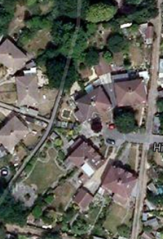

The application site is already the most cramped in the Close and development would diminish the spatial standards of the area.

Handout 2
[Address] and [application number]
Plans Sub-committee 5th June 2014
Submitted by [ ], of [ ]
Parking is already a major issue with the vehicles belonging to the applicant property already blocking access to other driveways and garages. (The blocked garage can just be seen behind the van). The situation would worsen with the loss of the parking space (i.e. garage).
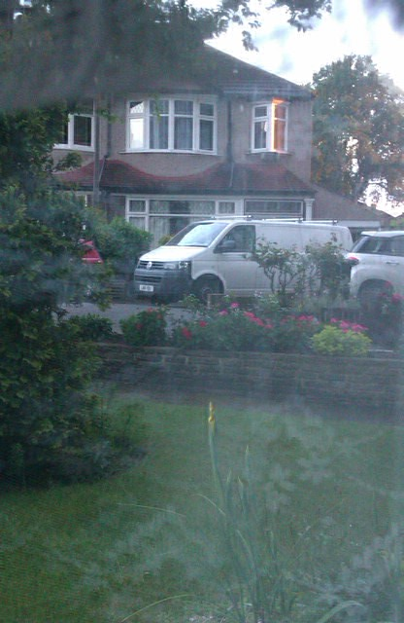
Access to the Close is already difficult along the narrow approach road:
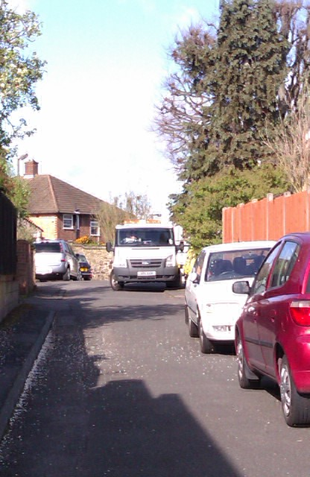

Handout 3
[Address]
Plans Sub-committee 5th June 2014
Submitted by [ ] of [ ]

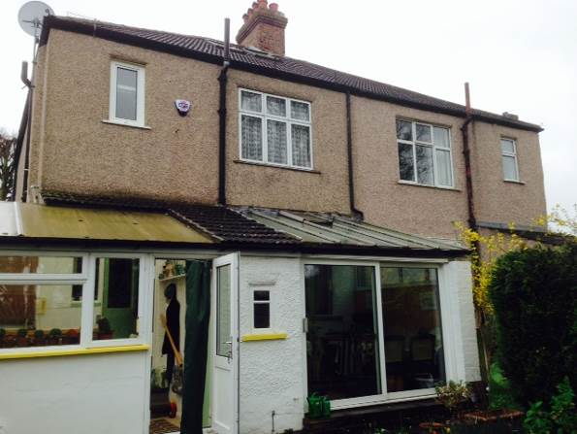
Indicative drawing
The dormer window will permit overlooking into, and a sense of dominance over, the small rear garden of No. 6.

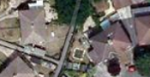
Above: looking down across and into the gardens and back rooms of neighbouring properties

